Faculty Guide for Accessibility

Why make your course accessible?
- Makes learning inclusive and improves comprehension
- Eliminates barriers to learning for individuals with disabilities
- Reduces issues needed to fix for accommodations
- Saves time when done proactively when content is first developed

Accessibility Concepts

 Organization
Accessibility Purpose: Provides clear order of navigation and identifies the purpose of content. Also aids individuals with cognitive disabilities or vision impairments.
- Use unique, descriptive titles for pages, documents, and slides
- Use consistent naming conventions
- Use consistent and clear layout of courses, webpages, and documents
- Add table of contents for long documents

Organization Resources
- The Basics of Accessible Digital Content Structure
- Layout and Hierarchy
- Video: Creating Accessible File Names
- Writing Document Titles for HTML
- Add a Title, Heading, or Table of Contents in Google Docs
- Add a Table of Contents in Word

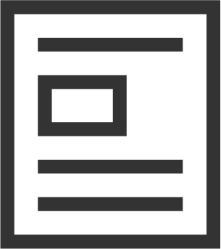 Headings
Accessibility Purpose: Improves scannability of pages and identifies topics for information. Also aids individuals with cognitive disabilities or vision impairments.
- Format headings correctly with heading styles
- Do not skip heading levels

Heading Resources
- Headings and Subheadings
- AccessibleU: Headings
- How to Add Headings in Canvas
- How to Add Headings in Microsoft Word
- Video: How to Add Headings in Microsoft Word
- Using Headings in Wordpress Sites

 Hyperlinks
Accessibility Purpose: Explains where links direct to and their purpose, and improves ability to identify links. Also aids individuals with vision and motor impairments.
- Hyperlink links to descriptive, meaningful text
- Avoid vague phrases such as “click here” or “link”
- Underline, bold, use a different color for links to make them easy to identify
- Periodically check links to confirm whether they are broken

Hyperlink Resources
- AccessibleU: Links
- Video: How to Create Accessible Links in Word
- How to Add Hyperlinks in Canvas
- How to Add Hyperlinks in PowerPoint
- How to Write Descriptive and Accessible Hyperlinks
- What’s Wrong with “Click Here” Links?

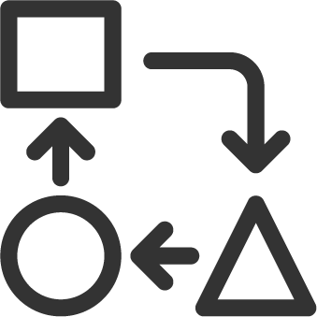 Reading Order & Orientation
Accessibility Purpose: Identifies correct flow of information for individuals using screen readers or text-to-speech software (including individuals with cognitive or vision impairments).
- Identify correct reading order of content
- Add content in-line and in a linear order
- Do not use content that is sideways (e.g. scanned materials)

Reading Order & Orientation Resources
- How to Edit Reading Order in PowerPoint and Acrobat
- How to Use the Reading Order Pane in PowerPoint
- Reading Order Tool for PDFs

 Page Layout
Accessibility Purpose: Improves readability and comprehension for all learners, including individuals with cognitive and vision impairments.
- Use white space for content and do not crowd elements together
- Use margins on documents
- Recommended to use line spacing of 1.5 or double spacing

Text Layout Resources
- Whitespace: Not Just a Waste of Space!
- Whitespace and Text Alignment
- Margins, Padding, and Whitespace

 Text Alignment
Accessibility Purpose: Improves readability and comprehension for all learners, including individuals with cognitive impairments.
- Left align text (for languages read left to right, e.g. English)
- Avoid centering text (centering is acceptable for titles)
- Do not justify text

Text Alignment Resources
- Text Block Formatting
- Text Alignment

 Text Emphasis
Accessibility Purpose: Improves readability and comprehension for all learners, including individuals with cognitive and vision impairments.
- Use bold for emphasis
- Do not use italics, underline, all caps, or a combination for emphasis

Text Emphasis Resources
- Bold Instead of Italics
- Emphasized Text

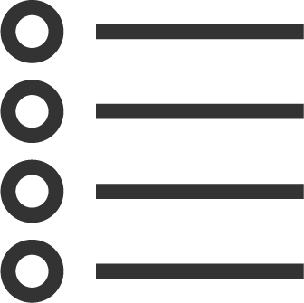 Lists
Accessibility Purpose: Improves readability and comprehension for all learners, including individuals with cognitive and vision impairments.
- Format lists with list styles
- Format nested lists as an outline or with headings

List Resources
- AccessibleU: Lists
- Lists in HTML
- Lists in Word

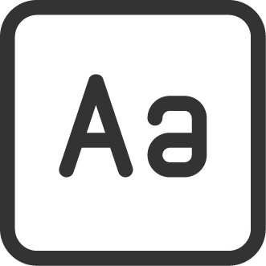 Font
Accessibility Purpose: Improves readability and comprehension for all learners, including individuals with cognitive disabilities.
- Use accessible fonts (Arial recommended)
- Use sans serif fonts; avoid serif and decorative fonts
- Select fonts available on all devices

Font Resources
- Font Face
- Best Fonts to Use on Your Website

 Language & Symbols
Accessibility Purpose: Improves readability and comprehension. Also aids individuals with cognitive or vision impairments, and English language learners.
- Add language tags to documents
- Avoid jargon, abbreviations, and idioms
- Spell out acronyms on first reference and use periods if possible (e.g. US vs U.S.)
- Avoid use of special characters and symbols
- Format math equations with Math Editors, MathML, or alt text

Language & Symbol Resources
- Content Language Accessibility in Canvas and Microsoft Office
- Foreign Languages and Accessibility
- Abbreviations in HTML
- Screen Readers: A Guide to Punctuation and Typographic Symbols
- Equations: MathML, Images and LaTeX
- Canvas Math Editor
- Math and Technical Content Guidelines

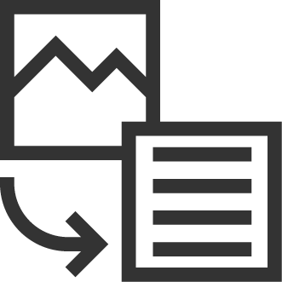 Images
Accessibility Purpose: Allows individuals with cognitive or vision impairments, or individuals with slow internet connections to read content.
- Add alt text for all images, shapes, graphs, etc. to describe their purpose
- Phrase alt text to be brief, descriptive, and concise
- Do not write “image of” or “graphic of” in alt text
- Do not use file name as alt text
- Avoid images of text (should be formatted as text)
- Mark images with no instructional purpose as decorative
- Add a detailed description or caption for complex images (in addition to alt text)
- Change complex images to a different format if they cannot be easily described with a combination of alt text and detailed description
- Provide a text alternative for scanned documents
- Add titles and axis labels for graphs and charts

Image Resources
- AccessibleU: Alt Text
- Video: How to Add Alt Text in Word
- Video: How to Add Alt Text in Outlook
- Video: Improve Image Accessibility in PowerPoint
- How to Design Great Alt Text
- Long Description for Images
- Flowcharts
- Decorative Images

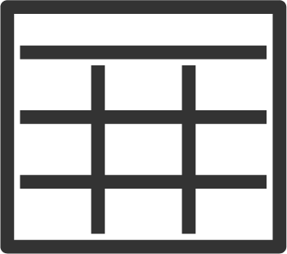 Tables
Accessibility Purpose: Improves table readability for all learners, including individuals with cognitive and vision impairments.
- Use tables only for data presentation and analysis
- Avoid using tables for text or page formatting (aesthetic purposes)
- Add a caption or description for tables
- Use headers for tables
- Avoid complexly formatted tables
- Repeat header row across pages
- Avoid blank or merged cells
- Add table alt text

Table Resources
- AccessibleU: Tables
- Video: How to Create Accessible Tables in Word
- Video: How to Create Accessible Tables in Excel
- Video: How to Create Accessible Charts in Excel
- How to Create Accessible Tables in Canvas
- Accessibility in Google Sheets

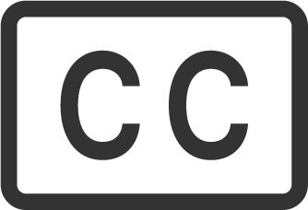 Multimedia
Accessibility Purpose: Provides text for individuals with hearing impairments, those in quiet or loud environments, or English language learners.
- Provide closed captions for videos
- Edit automatic captions for clarity
- Include a written transcript for audio recordings
- Describe images aloud during video or audio lectures
- Do not use videos with blinking or flickering content

Multimedia Resources
- AccessibleU: Video and Audio
- Editing Captions in MyMedia
- Creating Accessible Videos
- Accessibility Best Practices for Zoom

 Contrast
Accessibility Purpose: Improves readability for all learners, including those with vision impairments, color blindness, or individuals printing in black and white.
- Use a variety of color intensities
- Avoid using blurry images
- Avoid pastels and light colored text
- Avoid extremely bright colors
- Avoid textured backgrounds

Contrast Resources
- AccessibleU: Contrast
- Video: Use More Accessible Colors and Styles in PowerPoint
- Contrast Tips

 Color
Accessibility Purpose: Improves readability for all learners, including those with vision impairments, color blindness, or individuals printing in black and white.
- Avoid red/green color combinations
- Recommended to use monochrome coloring for graphs
- Avoid color coding information unless an additional method is used
- Add dashes lines or symbols to graphs

Color Resources
- Avoiding Color Coding
- Problematic Color Combinations
- Vibrating Color Combinations
- Charts and Accessibility

